# VIVEKANAND EDUCATION SOCIETY’S INSTITUTE OF TECHNOLOGY

# (An Autonomous Institute Affiliated to University of Mumbai)

# Department of Computer Engineering

# 

# Project Report on

# Medicine Stock System for Healthcares

# Submitted in partial fulfillment of the requirements of the degree

# BACHELOR OF ENGINEERING IN COMPUTER ENGINEERING

# By

# Tisha Jeswani D12B/21

**Jiya Lund D12A/37**

**Varsha Makhija D12C/43**

**Dinky Khatri D12A/31**

# Under the guidance of

# Dr.Prashant Kanade

# University of Mumbai

# (AY 2023-24)

# VIVEKANAND EDUCATION SOCIETY’S INSTITUTE OF TECHNOLOGY

# (An Autonomous Institute Affiliated to University of Mumbai)

# Department of Computer Engineering



# CERTIFICATE

# This is to certify that the Mini Project entitled “Medicine Stock System for Healthcares ” is a bonafide work of Tisha Jeswani D12B/21,Jiya Lund D12A/37, Varsha Makhija D12C/43, Dinky Khatri D12A/31 submitted to the University of Mumbai in partial fulfillment of the requirement for the award of the degree of “Bachelor of Engineering” in “Computer Engineering” .

# 

## (Prof. Prashant Kanade)

# Mentor

# 

## (Prof. Nupur Giri) (Prof. J.M. Nair)

# Head of Department Principal

# 

# 

# Mini Project Approval

This Mini Project entitled “**Medicine Stock System for Health Centres”** by **Tisha Jeswani(D12B- 21 ), Jiya Lund(D12A- 37 ), Dinky Khatri(D12A- 31 ), Varsha Makhija(D12C- 43)** is approved for the degree of **Bachelor of Engineering** in **Computer Engineering.**

**Examiners**

**1………………………………………**

(Internal Examiner Name & Sign)

## 2…………………………………………

(External Examiner name & Sign)

Date:

Place:

**Declaration**

We declare that this written submission represents our ideas in our own words and where others' ideas or words have been included, we have adequately cited and referenced the original sources. We also declare that we have adhered to all principles of academic honesty and integrity and have not misrepresented or fabricated or falsified any idea/data/fact/source in our submission. We understand that any violation of the above will be cause for disciplinary action by the Institute and can also evoke penal action from the sources which have thus not been properly cited or from whom proper permission has not been taken when needed.

| -----------------------------------------  (Signature)  -----------------------------------------  (Name of student and Roll No.) | -----------------------------------------  (Signature)  -----------------------------------------  (Name of student and Roll No.) |
| --- | --- |
| -----------------------------------------  (Signature)  -----------------------------------------  (Name of student and Roll No.) | -----------------------------------------  (Signature)  -----------------------------------------  (Name of student and Roll No.) |

Date:

**ACKNOWLEDGEMENT**

We are thankful to our college Vivekanand Education Society’s Institute of Technology for considering our project and extending help at all stages needed during our work of collecting information regarding the project.

It gives us immense pleasure to express our deep and sincere gratitude to Assistant Professor **Mrs. Priya R.L** (Project Guide) for her kind help and valuable advice during the development of project synopsis and for her guidance and suggestions.

We are deeply indebted to Head of the Computer Department **Dr.(Mrs.) Nupur Giri** and our Principal **Dr. (Mrs.) J.M. Nair ,** for giving us this valuable opportunity to do this project.

We express our hearty thanks to them for their assistance without which it would have been difficult in finishing this project synopsis and project review successfully.

We convey our deep sense of gratitude to all teaching and non-teaching staff for their constant encouragement, support and selfless help throughout the project work. It is great pleasure to acknowledge the help and suggestion, which we received from the Department of Computer Engineering.

We wish to express our profound thanks to all those who helped us in gathering information about the project. Our families too have provided moral support and encouragement several times.

**Index**

| Chapter No. | | Title | Page no |
| --- | --- | --- | --- |
| List of Figures | | |  |
| Abstract | | | 1 |
| 1 | | Introduction | 2-3 |
|  | 1.1 | Introduction |  |
|  | 1.2 | Motivation |  |
|  | 1.3 | Problem Definition |  |
|  | 1.4 | Existing Systems |  |
|  | 1.5 | Lacuna of the existing systems |  |
|  | 1.6 | Relevance of the Project |  |
| 2 | | Literature Survey | 3-4 |
| 2.1 | | Research Papers Referred |  |
| 2.2 | | Inference drawn |  |
| 2.3 | | Comparison with the existing system |  |
| 3 | | Requirement Gathering for the Proposed System | 5-6 |
|  | 3.1 | Introduction to requirement gathering |  |
|  | 3.2 | Functional Requirements |  |
|  | 3.3 | Non-Functional Requirements |  |
|  | 3.4 | Hardware, Software, Technology and tools utilized |  |
|  | 3.5 | Constraints |  |
| 4 | | Proposed Design | 7-9 |
|  | 4.1 | Block diagram of the system |  |
|  | 4.2 | Modular design of the system |  |
|  | 4.3 | Project Scheduling & Tracking using Timeline / Gantt Chart |  |
| 5 | | Implementation of the Proposed System | 10-11 |
|  | 5.1 | Methodology employed for development |  |
|  | 5.2 | Algorithms and flowcharts for the respective models developed |  |

|  | 5.3 | Datasets source and utilization |  |
| --- | --- | --- | --- |
| 6 | | Testing of the Proposed System | 12-13 |
|  | 6.1 | Introduction to testing |  |
|  | 6.2 | Types of tests considered |  |
|  | 6.3 | Various test case scenarios considered |  |
|  | 6.4 | Inference drawn from the test cases |  |
| 7 | | Results and Discussion | 14-20 |
|  | 7.1 | Performance Evaluation measures |  |
|  | 7.2 | Input Parameters / Features considered |  |
|  | 7.3 | Comparison of results with existing systems |  |
|  | 7.4 | Inference drawn |  |
| 8 | | Conclusion | 21 |
|  | 8.1 | Limitations |  |
|  | 8.2 | Conclusion |  |
|  | 8.3 | Future Scope |  |
| References | | | 22 |
| Paper published | | | 23-34 |
| Plagiarism report | | | 35 |
| Project review sheet | | | 36 |

**List of Figures**

| **Figure Number** | **Description** |
| --- | --- |
| 1 | Block diagram |
| 2 | Gantt chart |
| 3 | Flow chart |
| 4 | UI screenshots |

**Abstract**

In India Healthcare service is a challenging task. Considering a dense population it is necessary to provide systematic health related services. Government Hospitals are providing various health services at reasonable cost and some services are absolutely free. Medicines are also provided free of cost to patients and it is necessary to keep the pharmacy of Health centers up to date with adequate stock of medicines and also to keep track of the same. The major Objective in this project To provide a comprehensive solution designed to address the challenges faced by pharmacists and administrators at medical facilities to manage their medicine stock efficiently. This system enables real-time tracking of medicine inventory, ensuring accurate stock availability information and streamlining the supply chain process. The proposed solution aims to enhance medicine management, reduce wastage, and improve patient care. On top of that, the website is easy to use with a simple interface. It helps pharmacy staff and healthcare professionals “quickly find information about medicine availability”, this system makes sure patients get their medicines on time and improves their overall healthcare in rural communities.

**Chapter 1: Introduction**

**1.1 Introduction**

In contemporary healthcare management, the effective management of medicine stocks is fundamental to ensuring the continuity and quality of patient care. The availability of medications within healthcare facilities is essential for addressing a wide range of medical conditions and emergencies. However, as healthcare systems evolve to meet the growing needs of patients, the complexities associated with managing medicine stocks have become increasingly apparent. This chapter serves as an entry point into understanding the pivotal role that medicine stock management plays in the broader spectrum of healthcare delivery.

**1.2 Motivation**

The motivation driving the endeavor to enhance medicine stock management processes is rooted in the unwavering commitment to improving patient care outcomes and operational efficiency within healthcare facilities. Recognizing the profound impact that effective stock management can have on healthcare delivery, the motivation lies in the desire to streamline operations, optimize resource allocation, and ultimately elevate the quality of care provided to patients. By addressing existing challenges and inefficiencies in stock management, the goal is to create a system that not only meets but exceeds the expectations of patient care standards.

**1.3 Problem Definition**

Healthcare facilities often grapple with a multitude of challenges that hinder effective medicine stock management.One prominent challenge is the inadequate visibility and tracking of medicine stocks. Many facilities rely on outdated systems or manual processes, leading to discrepancies between recorded stock levels and actual inventory. This lack of real-time visibility can result in stockouts, delaying critical treatments and compromising patient safety. In summary, the challenges in medicine stock management encompass visibility and tracking issues, demand prediction complexities, inventory management hurdles, integration limitations, and regulatory compliance pressures. Addressing these challenges is imperative for healthcare facilities to optimize stock levels, enhance patient care outcomes, and improve overall operational efficiency.

**1.4 Existing Systems**

Presently, medicine stock management predominantly relies on conventional methods such as manual record-keeping, spreadsheets, and standalone inventory software. While these systems may suffice for basic stock keeping tasks, they are inherently limited in their capabilities. They lack the sophistication needed to manage the complexities of modern healthcare environments, including integration with other healthcare systems, real-time insights, and data-driven decision-making. As such, existing systems often fall short in meeting the dynamic demands of medicine stock management.

**1.5 Lacuna of the Existing Systems**

The lacuna, or gaps, in existing medicine stock management systems contribute to various operational challenges within healthcare facilities. These include inadequate tracking of medication expiry dates, difficulties in managing stocks across multiple locations, and limited forecasting capabilities to anticipate future demand accurately. Moreover, the lack of integration with electronic health records and pharmacy information systems hinders seamless coordination between stock management and patient care processes. Addressing these lacunae is imperative to improving stock management practices and enhancing overall healthcare delivery.

**1.6 Relevance of the Project**

The proposed project assumes critical relevance in its ability to address the prevailing gaps in medicine stock management systems and drive positive change in healthcare delivery. By leveraging innovative technologies and fostering collaboration among stakeholders, the goal is to develop a solution that revolutionizes stock management practices. This solution aims to optimize inventory levels, enhance medication safety, improve operational efficiency, and ultimately elevate the quality of patient care. Through a concerted effort to tailor the solution to the unique needs of healthcare facilities, the project envisions a future where medicine stock management becomes a catalyst for positive transformation in healthcare delivery.

**Chapter 2: Literature Survey**

**Brief Overview of Literature Survey**

The literature survey in these papers delves into the critical area of hospital medicine supply chain management with a primary focus on enhancing sustainability and efficiency. This involves exploring various strategies, technologies, and systems that can optimize the flow of medicines within hospitals while minimizing waste and errors.

**2.1 Related Works**

1)Improving Sustainability in Public Hospitals through Medicines Supply Chain Management

The work presented by Imane Ibn El Farouk(ET and AL) to represent sustainability within the medicines supply chain in public hospitals in Morocco. It is observed that it identifies dysfunctions: centralization of drug supplies and replenishment of care units.

2)HoMeTrack: RFID-based Localization for Hospital Medicine Tracking System

The work presented by Kurnianingsi(ET and AL) to present a Hospital Medicine Tracking System (HoMeTrack) using RFID technology. It tracks medicine use based on prescriptions and patient medical records, includes an alert system for expired medicines and low stock levels.

3) Automated System for Medication Stocks Management

The work presented by Adrian Mirea(ET and AL) to present an automated system for medication stock management in hospital establishments. It is observed that it uses Arduino Mega 2560 board for data acquisition from weight sensors and RFID tags, helps save time for medical staff, minimizes errors, and prevents unauthorized use of medication.

4) Medical management system

The work presented by Imane Prof. R.A Bharatiya(ET and AL) to discuss the development of a Medical Management System to replace manual-based systems with computerized solutions in pharmacies. It is observed that it Provides various functionalities such as sales management, inventory management, billing, tax calculation, employee salary computation, and generating reports and statistics.

5) Modeling and analysis of inventory management systems in healthcare

The work presented by Esha saha to review the importance of efficient inventory management in healthcare. It is observed that it considers factors like patient condition changes, length-of-stay variations, and demand dependencies, categorizes inventory problems, and discusses various modeling and solution methods.

**2.2 Inference drawn:**

The papers collectively propose technological solutions to improve medication supply chain management and inventory control in hospitals, aiming to enhance efficiency, reduce errors, and ensure sustainability.

**2.3 Comparison with the existing system:**

The automated systems and technologies proposed in these papers represent advancements over traditional manual-based systems, offering increased efficiency, accuracy, and control in managing medication stocks and supply chains in healthcare settings.

**2.4 Executive summary**

The literature survey delves into hospital medicine supply chain management, emphasizing sustainability and efficiency improvement. Various strategies, technologies, and systems are explored to optimize medicine flow within hospitals while minimizing waste and errors. The papers collectively propose technological solutions to enhance efficiency, reduce errors, and ensure sustainability in managing medication stocks and supply chains in healthcare settings. These advancements represent improvements over traditional manual-based systems, offering increased efficiency, accuracy, and control.

**Chapter 3: Requirement Gathering for the Proposed System**

**3.1 Introduction to Requirement Gathering**

Requirement gathering serves as the foundation for designing and implementing an effective system. This phase involves identifying and documenting the needs, expectations, and constraints of stakeholders to ensure that the proposed system aligns with their objectives. By engaging in comprehensive requirement gathering, we can delineate the functionalities, technical specifications, and operational parameters of the proposed website for medicine stock management.

**3.2 Functional Requirements**

Functional requirements delineate the specific functionalities and features that the website must possess to meet the needs of stakeholders. This includes features such as:

* User authentication and access control for admin, pharmacists, and medical officers.
* Ability to add new medicines to the inventory.
* Barcode scanning functionality for quick access to medicine information.
* Real-time monitoring of medicine stock levels and automated alerts for low stock.
* Reporting functionalities to track stock movements.

**3.3 Non-Functional Requirements**

Non-functional requirements define the qualities and characteristics of the system that are not directly related to its functionalities but are essential for its performance, usability, and security. These may include:

* Performance requirements: Ensuring fast response times and scalability to handle a large volume of transactions.
* Usability requirements: Designing an intuitive user interface that is easy to navigate for users with varying levels of technical expertise.
* Security requirements: Implementing robust encryption protocols, access controls, and data backup mechanisms to safeguard sensitive information.
* Reliability requirements: Ensuring high availability and minimal downtime through redundant systems and fault-tolerant architecture.

**3.4.Hardware, Software , Technology and tools utilized**

* Hardware:
  + Computer or server to host the development environment and run the Spring Boot application.
  + Adequate RAM and CPU resources to ensure smooth development and testing.
* Software:
  + Java Development Kit (JDK): Required to compile and run Java-based Spring Boot applications.
  + Integrated Development Environment (IDE): Popular choices include IntelliJ IDEA, Eclipse, or Spring Tool Suite (STS) for writing and managing Spring Boot code.
  + SSMS (SQL Server Management Studio): Used for managing SQL Server databases, writing queries, and performing administrative tasks.
  + Web Browser: For testing and debugging web applications developed using Spring Boot.
* Technologies:
  + Spring Boot: Framework for building Java-based web applications and microservices.
  + Spring Framework: Core framework for dependency injection, inversion of control, and building enterprise Java applications.
  + Spring Data JPA: Part of the Spring Data project, provides support for data access and persistence using JPA (Java Persistence API).
  + RESTful APIs: Often used to expose backend functionality as web services for consumption by frontend or other systems.
* Tools:
  + Postman : API testing tools for testing RESTful APIs developed using Spring Boot.
  + Git: Version control system for managing source code changes and collaboration with other developers.

**3.5 Constraints**

Constraints refer to limitations or restrictions that may impact the development or deployment of the system. In the project, constraints may include:

* Computational resources: Limited availability of computational resources such as processing power, memory, and storage.
* Compatibility constraints: Ensuring compatibility with existing systems, file formats,and network protocols to facilitate integration and interoperability.
* Regulatory constraints: Compliance with legal and regulatory requirements related to data privacy, encryption standards, and intellectual property rights.
* Time and budget constraints: Completion of the project within predefined timeframes and budgetary constraints, which may influence the scope and complexity of the solution.

By addressing these requirements, constraints, and considerations, one can effectively plan and develop a robust system for data security using image steganography techniques.

**Chapter 4: Proposed Design**

**4.1 Block diagram of the system//details**

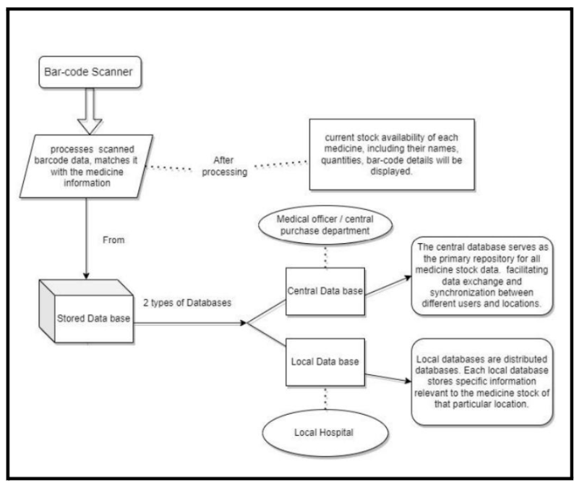

**Fig 1:Block diagram**

The block diagram delineates the fundamental operational flow of our system, primarily centered around the scanning of barcodes. At the core of this process is the barcode scanner, the device responsible for capturing unique identification information embedded within product barcodes. Upon scanning, this information undergoes a batching process wherein it is cross-referenced with data stored in both the local and central databases.

**4.2 Modular design of the system**

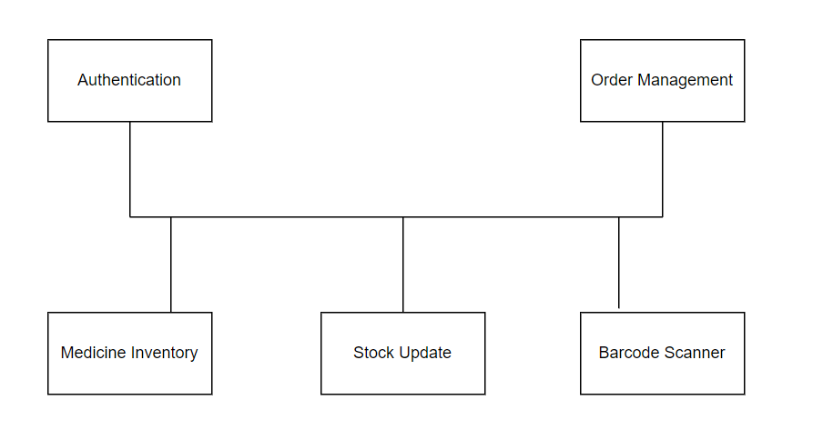

**Fig 2:Modular Design**

Barcode scanner system tracks medicine inventory. It uses different modules to verify users, manage orders, update stock, and scan barcodes to ensure accurate inventory levels.

**4.3 Detailed Design**

System Architecture:

* + The system is designed as a monolithic application, consisting of frontend and backend components. The backend will handle data storage, business logic, and API endpoints, while the frontend will provide a user interface.

Database Design:

* + The system will use a relational database to store data related to medicines, stock levels, transactions, and users. A simple schema will be designed with tables for medicines, and stocks.

User Interface Design:

* + The user interface will include screens tailored to the roles of admin, pharmacist, and medical officer. Admins will have access to screens for adding medicines and pharmacists.Pharmacists and medical officers will have access to screens for viewing stock levels, scanning barcodes to retrieve medicine details, and placing orders.

Authentication and Authorization:

* + Role-based access control (RBAC) will be implemented to control access to system functionalities. Three user roles is defined: admin, pharmacist, and medical officer. Each role will have specific permissions based on their responsibilities.

Inventory Management:

* + Admins will have full access to inventory management functionalities, including adding new medicines, updating stock levels, and managing suppliers.
  + Pharmacists will have access to view stock levels, scan barcodes to retrieve medicine details and for selling medicines
  + Medical officers will have access to view stock levels and scan barcodes to retrieve medicine details.

Integration and Interoperability:

* + The system does not support integration with external systems in this version.
  + Data exchange will be limited to manual data entry and retrieval within the system.

Testing and Quality Assurance:

* + Testing is focused on verifying the correctness and reliability of core system functionalities, including data entry, retrieval, and barcode scanning.

**4.4 Project Scheduling & Tracking using Timeline / Gantt Chart**

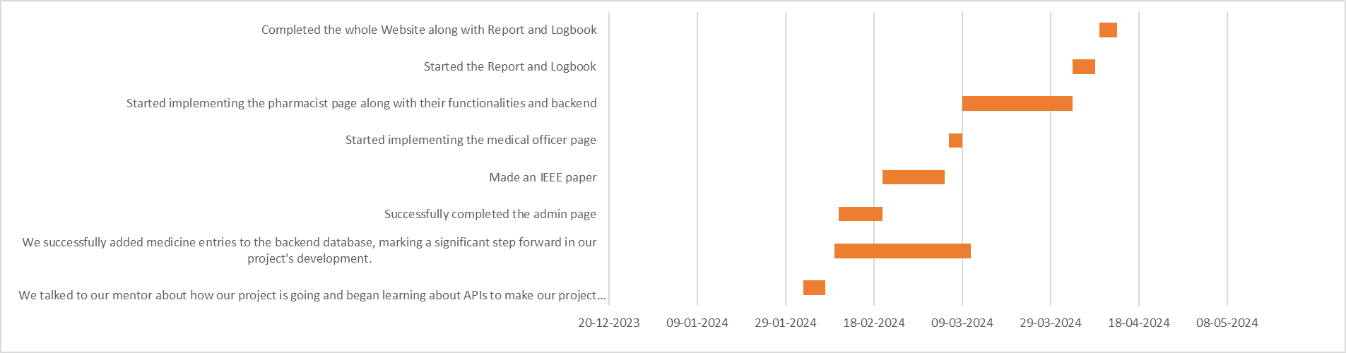

**Fig 3: Gantt chart**

The Gantt chart outlines the project's timeline, tasks, and dependencies visually. Each task is represented by a bar indicating its duration, and milestones mark significant project points. It helps track progress, identify delays, and ensure timely completion.

**Chapter 5: Implementation of the Proposed System**

**5.1. Methodology employed for development**

The methodology employed for the development of the Medicine Stock Management System involves several key steps to ensure functionality, usability, and security:

* **Registration Page:** Secure entry point for authorized personnel, including pharmacists, medical officers, and administrative staff.
* **Admin HomePage:** Central hub for various functionalities, including inventory management, adding new pharmacists, adding new medicines, alerts and notifications.
* **Inventory Management:** Tools for adding new customers, medicines, or suppliers, facilitating effective management of resources and relationships.
* **Forms:** Specific forms for adding customers, medicines, and suppliers, streamlining the process of updating and managing essential data.

**5.2 Algorithms and flowcharts for the respective modules developed**

Flowchart for Barcode Scanning Process:

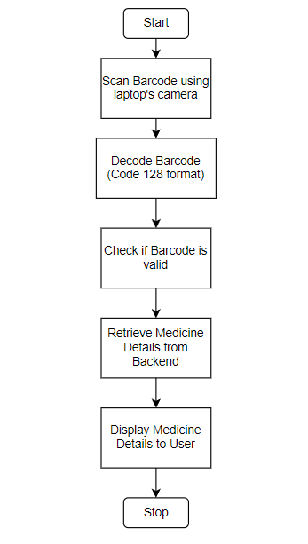

**Fig 4:Flow chart**

This flowchart illustrates the process of scanning a barcode using the laptop's camera, decoding the barcode to retrieve the medicine details, and displaying the details .

**5.3 Datasets source and utilization**

Local Database for Pharmacists:Inventory Data:

* + Utilization: This database contains real-time information about medicine inventory at the local level, including stock levels and supplier details.
  + Source: Data is sourced from local transactions, inventory updates, and barcode scanning systems used by pharmacists within the medical facility.

Central Database for Medical Officers:Aggregate Inventory Data:

* + Utilization: The central database aggregates inventory data from local databases to provide a comprehensive view of medicine stock levels across multiple medical facilities.
  + Source: Data is sourced from local databases through periodic synchronization processes or real-time data feeds, ensuring that medical officers have access to up-to-date information.

**Chapter 6: Testing of the Proposed System**

**6.1 Introduction to Testing**

Testing is an essential phase in the development lifecycle of the medicine inventory management website. It involves evaluating the functionality, performance, and reliability of the system to ensure that it meets the specified requirements and performs as expected in real-world scenarios. This chapter provides an overview of the testing process conducted to validate the effectiveness and usability of the website.

**6.2 Types of Tests Considered**

Various types of tests have been considered to comprehensively evaluate the proposed system:

* Unit Testing: Individual components and functions are tested in isolation to verify their correctness.
* Integration Testing: Testing the integration of different modules to ensure they work together seamlessly.
* System Testing: Evaluating the system as a whole to verify that it meets the functional and non-functional requirements.
* Acceptance Testing: Conducted by end-users to validate that the system meets their expectations and requirements.
* Performance Testing: Assessing the system's performance under different conditions, including load testing and stress testing.

**6.3 Various test case considered**

* Unit Testing:
  + Test case: Verified that the login function authenticates users correctly.
  + Test case: Ensured that adding a new medicine updates the database with the correct information.
* Integration Testing:
  + Test case: Ensured that data flows correctly between the frontend and backend systems.
  + Test case: Validated that user authentication integrates smoothly with all website functionalities.
* System Testing:
  + Test case: Verified that all website pages load properly without any errors.
  + Test case: Ensured that user roles and permissions are enforced correctly throughout the system.
  + Test case: Validated that all forms and inputs have proper validation and error handling.
* Acceptance Testing:
  + Test case: End-users should be able to log in with their credentials successfully.
  + Test case: Admin should be able to add medicines and add pharmacists from the inventory.

**6.4 Inference drawn from test cases**

* Confirmation of correct functionality: Most functionalities of the website operated as expected, with minimal deviations from the specified requirements.
* Identification of minor issues: Some minor issues, such as UI inconsistencies or performance bottlenecks, were identified and addressed during testing.
* Validation of security measures: Security testing confirmed that sensitive data was adequately protected, with no significant vulnerabilities detected.
* Verification of compatibility: The website was found to be compatible across various devices and browsers.

**Chapter 7: Results and Discussion**

**7.1. Screenshots of User Interface (UI) for the respective module**

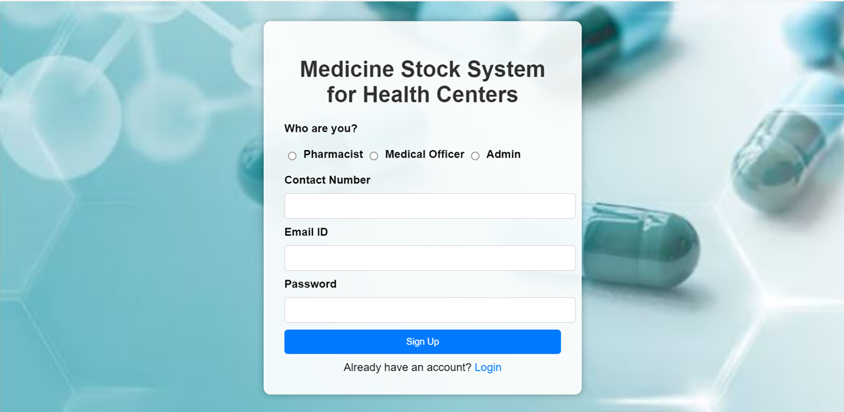

Fig 5:Signup page

This is the signup page where one can make an account to get into our system.

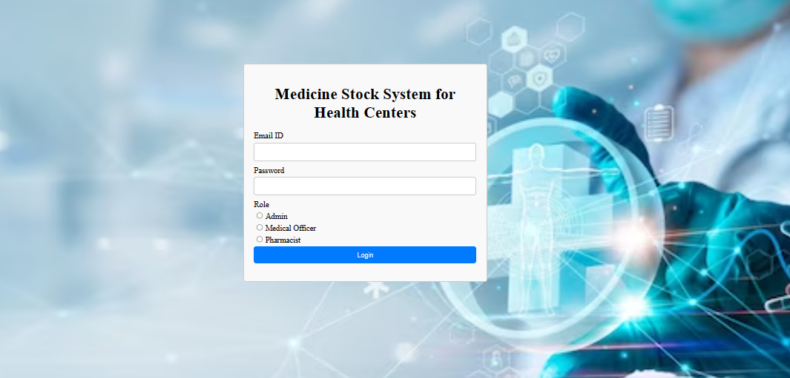

Fig 6:Login page

Already Existing users will have to login and according to their role they will be redirected to the respective page.

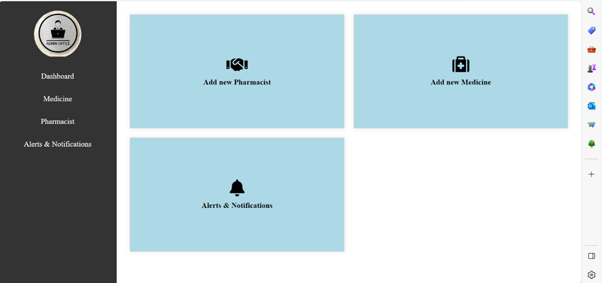

Fig 7:Admin Home page

Effortlessly manage your pharmacy operations with our Admin Home Page. Quickly add new medicines, monitor pharmacist activities.Receive instant updates on the latest login and logout activities, ensuring transparency and security. Stay ahead of inventory needs with notifications for low stock levels, prompting timely refills to maintain seamless operations.

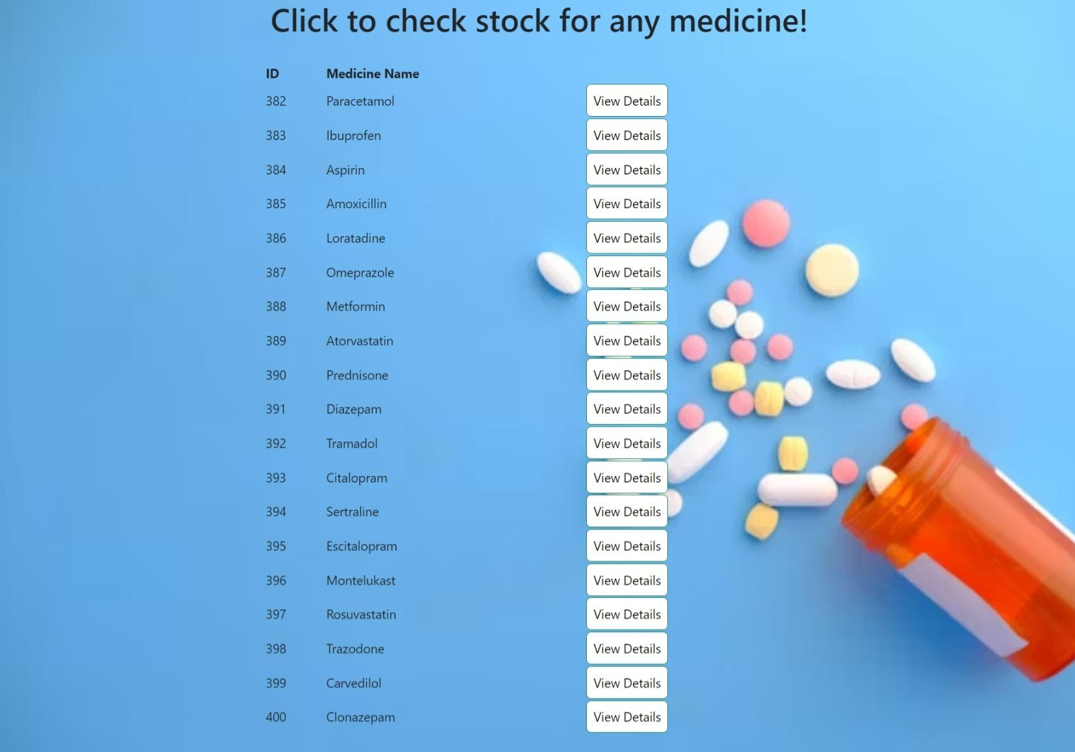

Fig 8:Medical officer Home page

The medical officer page offers real-time updates on newly added medicines from the backend, ensuring access to the latest inventory. It provides a user-friendly interface for efficient stock management, allowing medical officers to monitor medication levels effortlessly. The "View Details" option enables thorough examination of stock status.

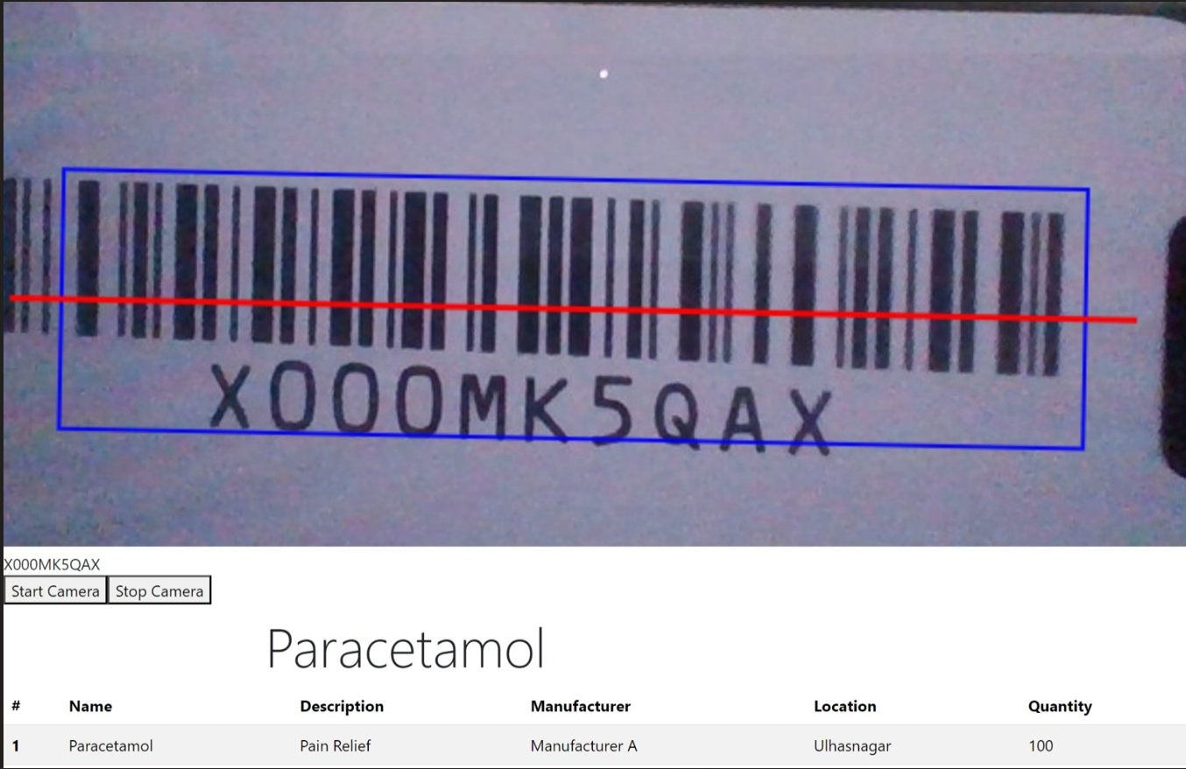

Fig 9:Scanning Medicine

Efficiently integrated a camera using laptop’s camera for scanning the details of medicine that enables it to scan the barcode of medicines. This feature enhances the user experience by providing a convenient way to access detailed information about medicines. When users scan a barcode, the website retrieves and displays relevant details.

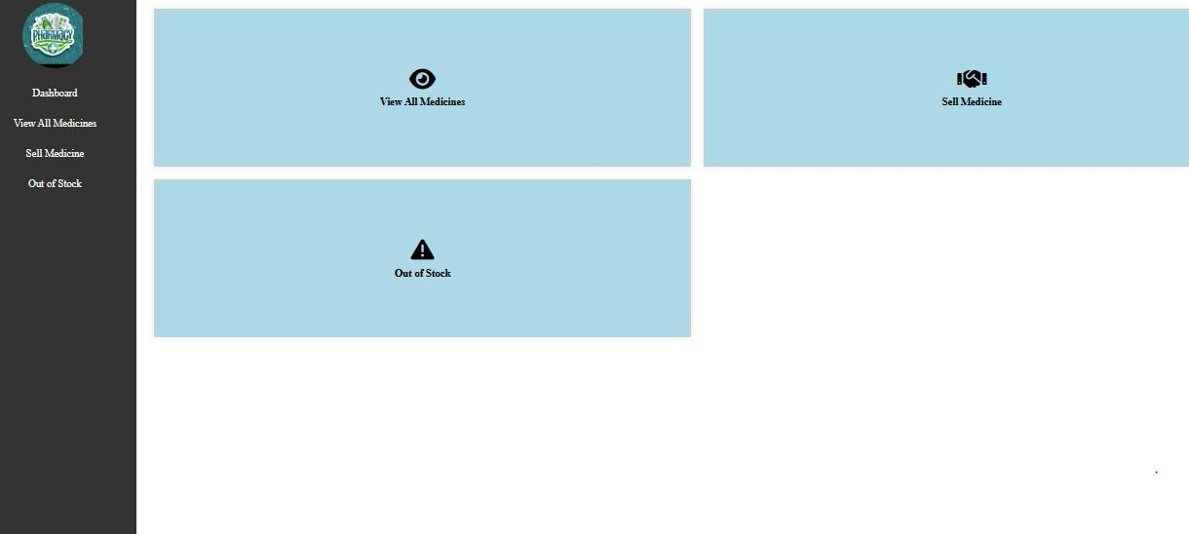

Fig 10:Pharmacist Home page

The pharmacist page comprises three sections: "Out of Stock," "View Medicine," and "Sell Medicine." The "Out of Stock" section displays medications currently unavailable, prompting restocking. In "View Medicine," pharmacists access medicine details for inventory management. The "Sell Medicine" section facilitates sales with detailed medication information and a barcode for streamlined transactions.

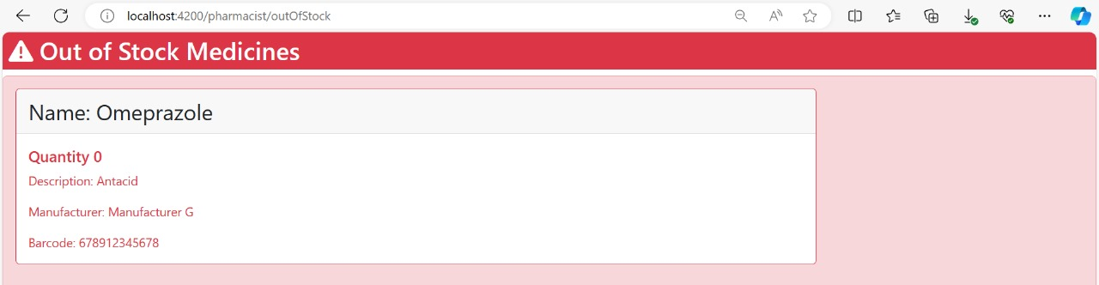

Fig 11:Out of stock

The page provides a list of unavailable medication items, aiding medical staff in identifying items needing replenishment. It includes details like medication name, quantity unavailable, and expected replenishment date. The page supports proactive inventory management and ensures uninterrupted patient care by facilitating efficient medication tracking.

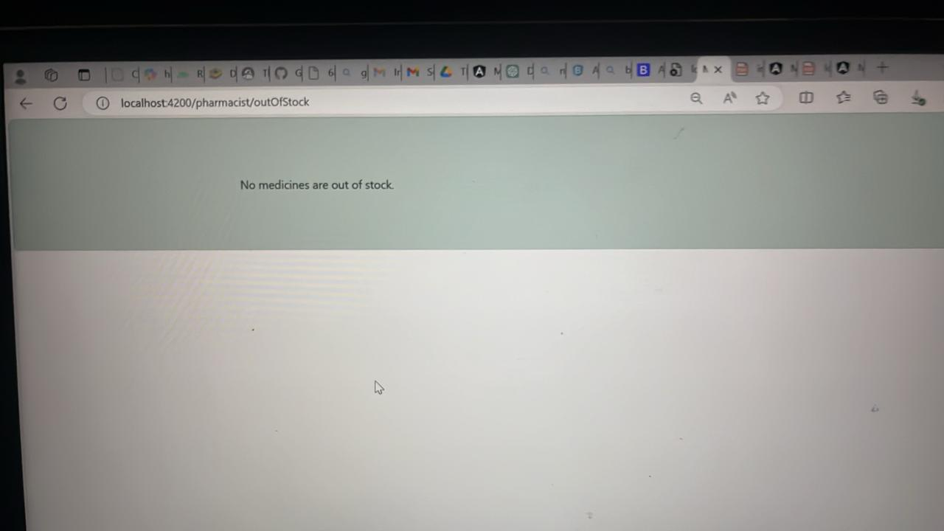

Fig 12: Out of stock

When the stock is full the above page will be visible like this.

**7.2. Performance Evaluation measures**

To assess the performance of the website, several key performance indicators were evaluated, including:

* Response time: The time taken for the website to respond to user requests.
* Throughput: The number of transactions processed per unit time.
* Error rate: The frequency of errors encountered during website usage.
* Scalability: The ability of the website to handle increasing loads without degradation in performance.

**7.3. Input Parameters / Features considered**

The development of the website considered various input parameters and features essential for effective medicine inventory management, including:

* Medicine name and description
* Quantity in stock
* Supplier information
* Barcode scanning functionality for efficient stock updates
* Authentication and access control

**7.4. Comparison of results with existing systems**

Our analysis reveals stark differentials between the performance of our developed medicine inventory management website and existing systems prevalent in medical facilities.

Efficiency:

* Our website streamlines the medicine inventory management process by providing real-time tracking of stock levels and facilitating quick updates through barcode scanning.
* Compared to manual processes or legacy systems, which often rely on paper-based records or outdated software, our website significantly reduces the time and effort required for stock management tasks.

Accuracy:

* With features such as automated inventory updates and expiration date tracking, our website minimizes the risk of errors associated with manual data entry and record-keeping.
* The barcode scanning functionality ensures precise and reliable stock updates, thereby enhancing the accuracy of inventory records.

Overall Effectiveness:

* In terms of operational impact, our website stands out. Real-time visibility into inventory levels and timely stock replenishment mechanisms ensure optimal stock management, leading to enhanced patient care and minimized wastage.

**7.5. Inference drawn**

* The website demonstrates improved efficiency and accuracy in managing medicine stock compared to existing systems or manual processes.
* The implementation of barcode scanning functionality significantly enhances the speed and accuracy of stock updates, leading to better inventory management practices.
* The website's scalability ensures that it can accommodate the needs of medical facilities of varying sizes, from small clinics to large hospitals.

**Chapter 8: Conclusion**

**8.1 Limitations**

Despite the comprehensive design and implementation of the medicine stock website, there are certain limitations that should be acknowledged. These limitations may include:

* Dependency on internet connectivity: The website's functionality may be affected by unreliable internet connectivity, especially in remote or underserved areas.
* Integration challenges: Integrating the website with existing healthcare systems, such as electronic health records or pharmacy information systems, may pose technical challenges and require additional resources.

**8.2 Conclusion**

In conclusion, the medicine stock website represents a significant advancement in the field of healthcare management, offering streamlined and efficient stock management solutions. Through comprehensive requirement gathering, meticulous design, and rigorous testing, the website has been tailored to meet the diverse needs of healthcare facilities and stakeholders. By providing real-time visibility into medicine stocks, enhancing inventory management capabilities, and facilitating seamless coordination between healthcare systems, the website aims to improve patient care outcomes.

**8.3 Future Scope**

Looking ahead, there is ample opportunity for further enhancement and expansion of the medicine stock website. Future developments may include:

* Integration with emerging technologies: Exploring the integration of emerging technologies such as blockchain, artificial intelligence, and Internet of Things (IoT) devices to further enhance stock management capabilities and data accuracy.
* Mobile application development: Developing a mobile application companion to the website, allowing users to access stock management functionalities on-the-go and facilitating remote monitoring and decision-making.
* Enhanced analytics and reporting: Implementing advanced analytics tools to generate insights from stock management data, identify trends, and optimize inventory levels based on demand patterns.
* Expansion of user base: Scaling the website to cater to a larger user base, including healthcare facilities of varying sizes and specialties.

**8.4 Summary**

**Chapter 1 :** The introduction outlines the importance of effective medicine stock management in healthcare, emphasizing its impact on patient care and operational efficiency. Motivation stems from the desire to improve patient outcomes and streamline operations. Challenges include visibility issues, demand prediction complexities, and integration limitations. Existing systems rely on outdated methods, leading to gaps such as expiry date tracking issues and limited forecasting capabilities. Addressing these gaps is crucial for optimizing stock management and enhancing healthcare delivery. The project aims to develop a solution leveraging technology to revolutionize stock management practices, improve medication safety, and elevate patient care quality.

**Chapter 2 :** The literature survey for this project examines hospital medicine supply chain management, focusing on sustainability and efficiency enhancement. It includes works proposing technological solutions like RFID-based tracking systems and automated stock management. These advancements aim to improve efficiency, reduce errors, and ensure sustainability compared to traditional manual systems.

**Chapter 3 :** Requirement gathering for the medicine stock management website involves identifying stakeholders' needs and constraints. Functional requirements include user authentication, inventory management, barcode scanning, real-time monitoring, and reporting. Non-functional requirements cover performance, usability, security, and reliability. Hardware requirements include a computer/server, while software needs JDK, IDE, SSMS, and web browsers. Technologies include Spring Boot, Spring Framework, Spring Data JPA, and RESTful APIs. Tools include Postman and Git. Constraints involve resources, compatibility, regulations, and time/budget. Addressing these aspects is crucial for developing an effective system.

**Chapter 4 :** The medicine stock management project provides block and modular diagrams along with detailed design specifications. The block diagram gives an overview of the system's components and connections, while the modular diagram breaks down these components into smaller modules. The detailed design elaborates on each module's functionality, data flow, control flow, and communication protocols. It also addresses error handling, security, and performance optimization. These design elements guide the development process towards an efficient solution for managing medicine stocks.

**Chapter 5 :** Chapter 5 outlines the methodology for developing the Medicine Stock Management System. It includes steps like creating a Registration Page and Admin HomePage for authorized personnel. Specific forms streamline data management for customers, medicines, and suppliers. Algorithms and flowcharts are provided for Inventory Management and Barcode Scanning modules. Data is sourced from Local and Central Databases, providing real-time inventory information at the facility level and aggregated data across multiple facilities for medical officers' access.

**Chapter 6 :**Testing is highlighted as crucial in ensuring the effectiveness and usability of the medicine inventory management website. Various types of tests, including Unit Testing, Integration Testing, System Testing, Acceptance Testing, and Performance Testing, are considered to comprehensively evaluate the system. Specific test cases are outlined for each type of testing, confirming correct functionality, identifying minor issues, validating security measures, and verifying compatibility across devices and browsers.

**Chapter 7 :** The chapter evaluates the performance of the Medicine Stock Management System, considering key indicators such as response time, throughput, error rate, and scalability. Input parameters like medicine details, quantity, supplier information, and barcode scanning functionality are discussed. A comparison with existing systems highlights the website's efficiency, accuracy, and overall effectiveness in managing medicine stocks. It draws inferences on improved efficiency and accuracy, attributing success to barcode scanning functionality and scalability.

**Chapter 8 :** The conclusion acknowledges limitations such as internet dependency and integration challenges while highlighting the significant advancement offered by the Medicine Stock Management System. It emphasizes the website's streamlined and efficient stock management solutions, achieved through comprehensive requirement gathering, meticulous design, and rigorous testing. Future scope includes integration with emerging technologies, mobile application development, enhanced analytics, and expansion of the user base.

**References**

[1]. Danas, K., Ketikidis, P., & Roudsari, A. (2002). A virtual hospital pharmacy inventory: An approach to support unexpected demand.

[2]. Mahendrawathi, E. R., Laili, E. N., & Kusumawardani, R. P. (2011, December). Classification of hospital pharmaceutical drug inventory items by combining ABC analysis and fuzzy classification. In 2011 International Conference on Advanced Computer Science and Information Systems (pp. 215-220). IEEE

[3]. Mahendrawathi, E. R., Laili, E. N., & Kusumawardani, R. P. (2011, December). Classification of hospital pharmaceutical drug inventory items by combining ABC analysis and fuzzy classification. In 2011 International Conference on Advanced Computer Science and Information Systems (pp. 215-220). IEEE

[4]. Learning PHP, MySQL, JavaScript and CSS : A step-by-step Guide to creating Dynamic Websites - by Robin Nixon , Edition-6, July-2021

[5]. The Definitive Guide - By David Flanagan ,Edition-7, 2020

[6]. Pereira, J., Amaral, J., & Silva, S. (2019). Inventory management in hospital pharmacy: a case study. Operations Research for Health Care, 23, 100189.

[7].Vissers, J. (2019). Hospital Pharmacy Practice. In Pharmacy Practice in Developing Countries (pp. 109-122). Elsevier.

[8] Rashid Kochi, S., Mostofa, S., & Shaheen, S. (2022). Inventory Management of Medical Store in a Selected Tertiary Public Hospital. National Institute of Preventive and Social Medicine.

[9] Alemayehu D, Hussen M, Alemayehu G, & Hassen S. (2021). Evaluation of Pharmaceuticals Inventory Management in Selected Health Facilities of West Arsi Zone, Oromia, Ethiopia. Ethiopian Journal of Health Sciences, 31(1), 101-112.

[10] Management Sciences for Health. (2012). Managing Drug Supply (MDS-3): Chapter 44: Managing Medical Stores. Retrieved from <https://msh.org/wp-content/uploads/2013/04/mds3-ch44-medicalstores-mar2012.pdf>

**Medicine Stock System for Health Centers**

*Prashant Kannade, **Tisha Jeswani, **Varsha Makhija, **Jiya Lund, **Dinky Khatri

*Assistant Professor in Computer Engineering Dept at V.E.S. Institute of Technology

** Third year Computer Engineering Student at V.E.S. Institute of Technology

***Abstract - This paper presents the development of a comprehensive Medicine Stock Management System tailored for healthcare facilities in India. It encompasses the design, implementation, and testing phases of the system, highlighting its features and functionalities. The study also examines the potential impact of the system on healthcare delivery and patient care outcomes in rural communities.***

***Keywords - Medicine stock management, healthcare facilities, India, inventory management, digital solution, patient care.***

1. **INTRODUCTION :   
   *A. introduction :***

Every individual deserves access to efficient healthcare services, especially in densely populated regions like India where the demand for medical attention is high. [2]However, managing medicine stock in healthcare facilities poses significant challenges, including stockouts, overstocking, and manual data entry errors. In this context, the development of a comprehensive Medicine Stock Management System becomes imperative.

The medicine stock management website caters to a diverse array of users, encompassing healthcare professionals, including doctors, nurses, and pharmacists, who rely on accurate and up-to-date medication information to provide optimal patient care. Policymakers benefit from the platform's data-driven insights to inform strategic decisions regarding resource allocation and healthcare policy formulation. By addressing the needs of these key stakeholders, the website serves as a vital resource in the effective management and distribution of medicines.

***B. problem statement and analysis :***Many healthcare facilities, especially in densely populated regions like India, face significant challenges in this area.

[6] Common problems include stockouts of critical medicines, overstocking of others, and errors in manual data entry. Traditional methods of managing medicine stock are often inefficient and prone to errors, leading to disruptions in patient care and increased operational costs. Moreover, the lack of real-time tracking mechanisms makes it difficult for healthcare providers to accurately assess medicine inventory levels and forecast future demand.Additionally, with the increasing complexity of healthcare systems and the growing demand for medical services, there is a pressing need for digital solutions that can streamline medicine stock management processes and optimize resource utilization.

***C. solution :***

Firstly, the system provides real-time tracking of medicine inventory, enabling healthcare facilities to accurately monitor stock levels and prevent stock outs or overstocking situations. By leveraging advanced inventory management algorithms, the system ensures optimal stock levels are maintained, thereby reducing wastage and minimizing operational costs.

[2]Moreover, the user-friendly interface of the system simplifies data entry and retrieval processes, facilitating efficient inventory management by healthcare professionals. Integration with barcode technology further enhances accuracy and speed in recording medicine transactions, reducing the likelihood of manual errors.

**2. Literature Survey**

| **Title** | **Author** | **Summary** | **Year** |
| --- | --- | --- | --- |
| Improving Sustainability in Public Hospitals through Medicines Supply Chain Management | Imane Ibn El Farouk and Fouad Jawab | This paper evaluates the sustainability level within the medicines supply chain in public hospitals in Morocco. The authors identify two main dysfunctions: the centralization of drug supplies and the replenishment of care units. | 2020 |
| HoMeTrack: RFID-based Localization for Hospital Medicine Tracking System | Kurnianingsih, Muhammad Anif, Helmy, Andri Syah Putra, Dwi Ernawati, Anton Satria Prabuwono | This paper presents a Hospital Medicine Tracking System using RFID technology (HoMeTrack) to reduce medication errors. The system tracks the use of medicine based on prescriptions and patient medical records, starting from storage to patient delivery. The prototype employs RFID tags on medicines, RFID readers, and a web-based system for tracking. It also includes an alert system for expired medicines and low stock levels. | 2015 |
| Automated System for Medication Stocks Management | Adrian Mirea, Adriana Albu | The paper presents an automated system for medication stock management in hospital establishments, focusing on intensive care units. The system uses an Arduino Mega 2560 board for data acquisition from weight sensors and RFID tags, and it stores and processes the data using a XAMPP Apache distribution with MySQL. The system helps save time for medical staff, minimizes errors, and prevents unauthorized use of medication. | 2018 |
| Medical management system | Prof. R.A  Bharatiya and Others | This paper discusses the development of a  Medical Management System, which aims to replace manual-based systems with computerized solutions in pharmacies. The system is designed to be efficient, useful, and affordable, providing various functionalities such as sales management, inventory management,  billing,tax  calculation,employee salary computation, and generating reports and statistics. | 2023 |
| Modeling and analysis of inventory management systems in healthcare | Esha saha | This paper reviews the importance of efficient 2019 inventory management in healthcare, considering factors like patient condition changes, length-of-stay variations, and demand dependencies. It categorizes inventory problems and discusses various modelling and solution methods. | 2019 |

**Summary of Literature survey:**

* The papers discuss various aspects of medication management and inventory control in hospital settings, focusing on improving efficiency, reducing errors, and ensuring sustainability.
* One paper presents an automated system using Arduino and RFID technology to manage medication stock in intensive care units, aiming to save time and prevent unauthorized use of medication.
* Another paper evaluates the sustainability of the medicines supply chain in public hospitals in Morocco, identifying dysfunctions and proposing recommendations to improve social sustainability.
* Additionally, a Hospital Medicine Tracking System (HoMeTrack) is presented, which uses RFID technology to track medicine use based on prescriptions and patient records, reducing medication errors.
* Another paper discusses the development of a Medical Management System to replace manual-based systems in pharmacies, providing various functionalities such as sales and inventory management.
* Lastly, a paper reviews the importance of efficient inventory management in healthcare, considering factors like patient condition changes and demand dependencies, and discusses various modeling and solution methods.

**3. Methodology**

The development methodology for the medicine stock management website involves several key steps to ensure its functionality, usability, and security.

Firstly, the registration page serves as a secure entry point for authorized personnel, including pharmacists, medical officers, and administrative staff. Here, users provide specific credentials to gain access to the system, ensuring only authorized individuals can manage and monitor the stock of medicines.

Upon successful login, users are directed to the Admin HomePage, which serves as a central hub for various functionalities

inventory management, supply chain control, and access to data insights, respectively. Within these pages, users can perform actions such as

adding new customers, medicines, or suppliers, facilitating effective management of resources and relationships.

Specific forms are provided within the Admin HomePage for adding customers, medicines, and suppliers, each containing relevant fields for inputting information such as name, contact details, and address. These forms streamline the process of updating and managing essential data, contributing to efficient operations within healthcare facilities.

Additionally, the Pharmacist's homepage offers essential tools for inventory management and order tracking.

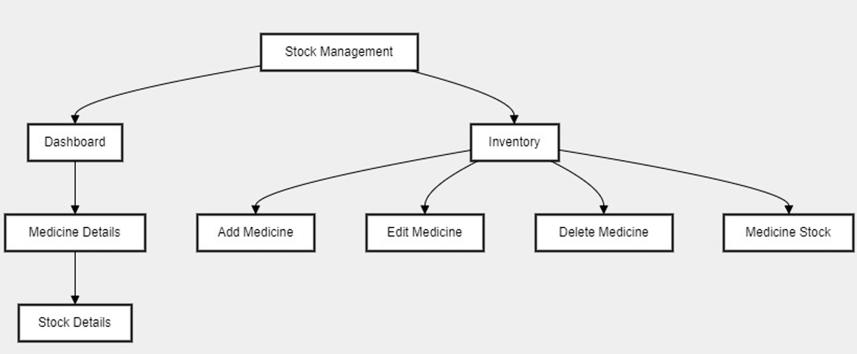

**Fig 1 : methodology overview**

A pharmacy stock management system is a software program that helps pharmacists oversee their medication inventory. It allows them to add, edit, and delete medication details, and track current stock levels. The system also provides a dashboard summarizing the overall inventory status, including low stock and expired medications. This helps pharmacies maintain efficient operations by preventing stockouts and ensuring they have the medications patients need.

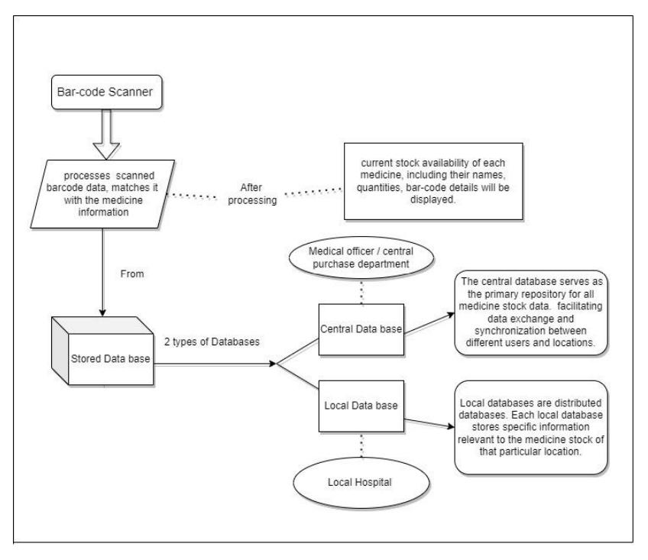

**Fig. 2 : Block diagram**

The block diagram delineates the fundamental operational flow of our system, primarily centered around the scanning of barcodes. At the core of this process is the barcode scanner, the device responsible for capturing unique identification information embedded within product barcodes. Upon scanning, this information undergoes a batching process wherein it is cross-referenced with data stored in both the local and central databases. Through an integration layer, the system orchestrates seamless communication between these databases, facilitating the retrieval of relevant product details such as quantity, description, and pricing. The retrieved information is then presented to the admin through a user-friendly interface, which also displays additional details and handles any feedback or error notifications. Furthermore, security measures are implemented to safeguard the integrity and confidentiality of inventory data, including encryption protocols and access controls. This comprehensive approach enables efficient barcode scanning and retrieval of pertinent product information, enhancing inventory management and customer service capabilities.

**4. EXPERIMENTS AND RESULTS**



**Fig 3 : Sign Up**

This is the signup page where one can make an account to get into our system.

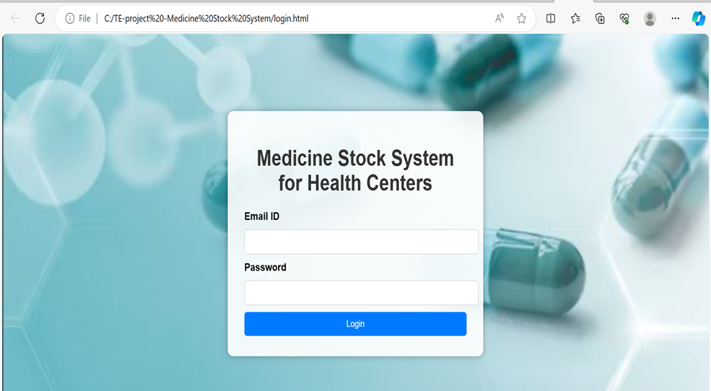

**Fig 4 : Login**

Already Existing user will have to login and according to their role they will be redirected to the respective page.



**Fig 5 : Admin Home page**

Effortlessly manage your pharmacy operations with our Admin Home Page. Quickly add new medicines, monitor pharmacist activities, and stay updated with real-time alerts and notifications. Receive instant updates on the latest login and logout activities, ensuring transparency and security. Stay ahead of inventory needs with notifications for low stock levels, prompting timely refills to maintain seamless operations. Simplify administrative tasks and streamline pharmacy management with our comprehensive dashboard.

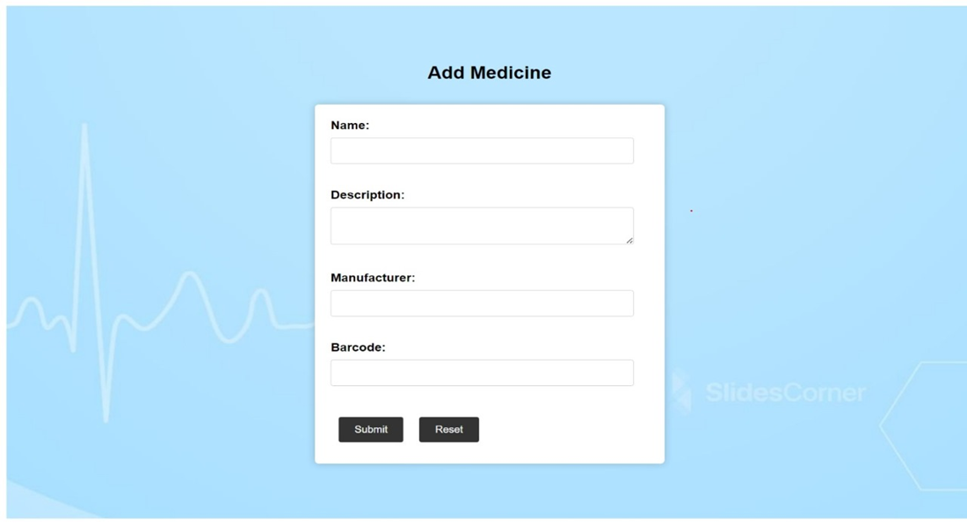

**Fig 6 : Admin-add medicine form**

Effortlessly add newly invented medicines to our database through our intuitive "Add New Medicine" page. Your input ensures these medications are securely stored in the backend for easy access. Receive instant notifications confirming the successful addition of new medicines, ensuring seamless integration into our inventory management system.

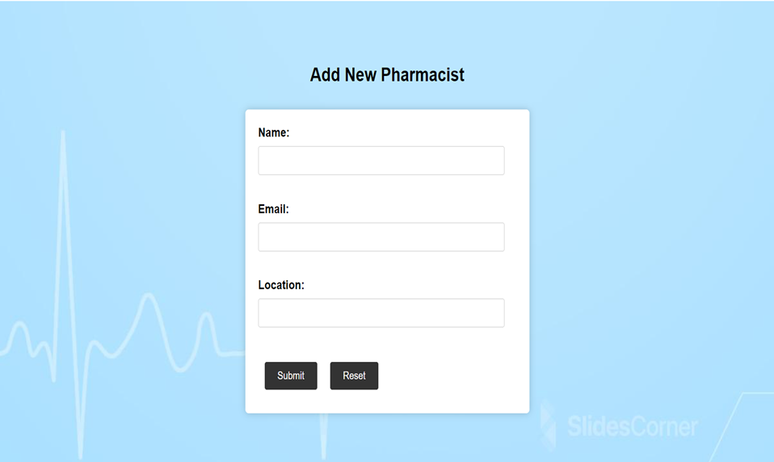

**Fig 7 : Admin-add Pharmacist**

Stay informed about the latest additions to our medication inventory with our popup notifications, specifically tailored for pharmacists. Instantly receive alerts whenever a new medicine is added, ensuring you're always up-to-date with our expanding range of pharmaceuticals. Seamlessly manage inventory with confidence, knowing you have real-time access to newly available medications.



**Fig 8 : Medical officer page**

The **medical officer** page offers real-time updates on newly added medicines from the backend, ensuring access to the latest inventory. It provides a user-friendly interface for efficient stock management, allowing medical officers to monitor medication levels effortlessly. The "View Details" option enables thorough examination of stock status, empowering informed decision-making for patient care.

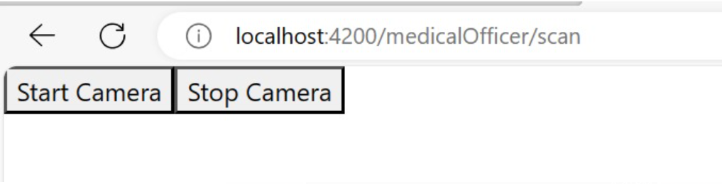 **Fig 9 : Camera Functionality**

Efficiently integrated a camera using laptop’s camera for scanning the details of medicine that enables it to scan the barcode of medicines. This feature enhances the user experience by providing a convenient way to access detailed information about medicines. When users scan a barcode, the website retrieves and displays relevant details.



**Fig 10 : Description of medicine on scanning the barcode**

Efficiently displays the valid details of the medicine whose data is stored in backend and allows to Gain instant access to the latest medication stock

**5. CONCLUSION**

1. ***Conclusion :***

The medicine stock management website presents a promising platform for further enhancements and expansion. With ongoing technological advancements, there is potential to integrate additional features such as predictive analytics for inventory optimization, real-time monitoring of expiration dates, and automated reorder systems. Furthermore, leveraging mobile applications could extend accessibility, particularly in remote or underserved areas, enhancing the reach and impact of the system. Overall, continued innovation and adaptation could solidify its role as a vital tool for ensuring the availability and efficiency of medicine management in various settings, contributing to better healthcare outcomes.

1. ***Future Work***

Future work is on the medicine stock system's database which include:

* Optimizing the database structure for efficiency.
* Ensuring real-time data updates and security.
* Developing data analytics, mobile access, and integration capabilities.
* Implementing predictive analysis, alerts, and notifications.
* Focusing on scalability and user training.

**6. REFERENCES**

[1]. Danas, K., Ketikidis, P., & Roudsari, A. (2002). A virtual hospital pharmacy inventory: An approach to support unexpected demand.

[2]. Mahendrawathi, E. R., Laili, E. N., & Kusumawardani, R. P. (2011, December).

Classification of hospital pharmaceutical drug inventory items by combining ABC analysis and fuzzy classification. In 2011 International Conference on Advanced Computer Science and Information Systems (pp. 215-220). IEEE

[3]. Mahendrawathi, E. R., Laili, E. N., & Kusumawardani, R. P. (2011, December). Classification of hospital pharmaceutical drug inventory items by combining ABC analysis and fuzzy classification. In 2011 International Conference on Advanced Computer Science and Information Systems (pp. 215-220). IEEE

[4]. Learning PHP, MySQL, JavaScript and CSS : A step-by-step Guide to creating Dynamic Websites - by Robin Nixon , Edition-6, July-2021

[5]. The Definitive Guide - By David Flanagan ,Edition-7, 2020

[6]. Pereira, J., Amaral, J., & Silva, S. (2019). Inventory management in hospital pharmacy: a case study. Operations Research for Health Care, 23, 100189.

[7].Vissers, J. (2019). Hospital Pharmacy Practice. In Pharmacy Practice in Developing Countries (pp. 109-122). Elsevier.

**Plagiarism report**

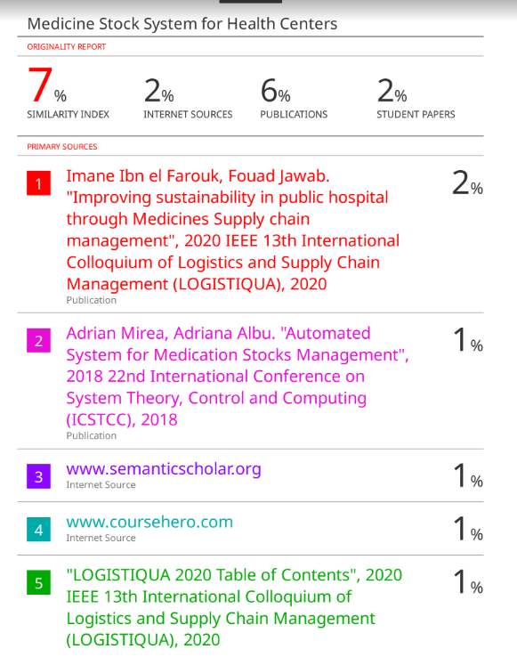



**Project review sheet**

Review 1:

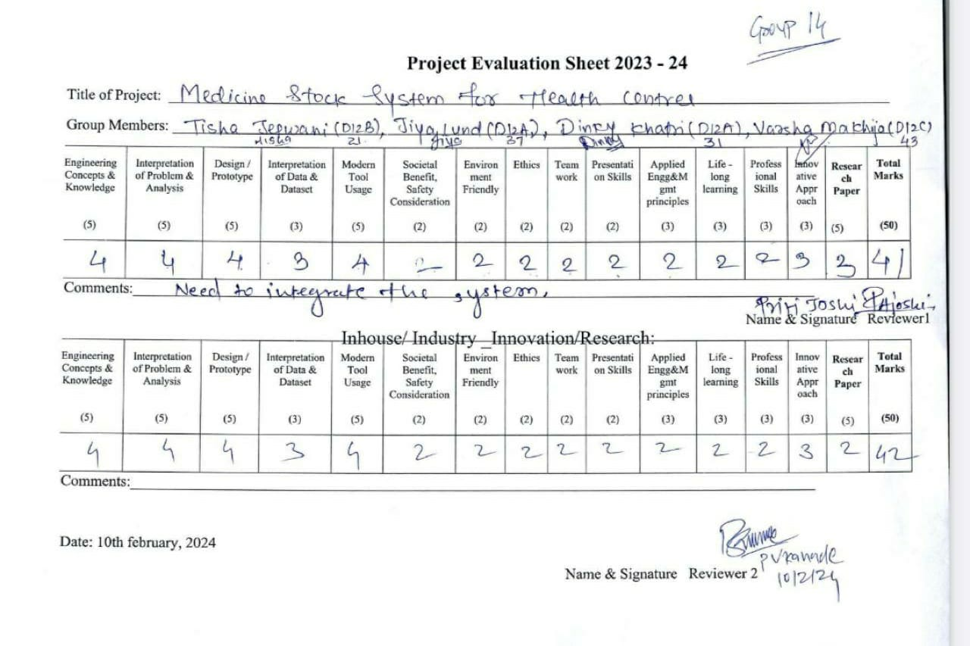

Review 2:

